case1

Problem statement:
Online Shopping Website
Online Shopping Website Create an e-commerce interface displaying products, prices, discounts, ratings, categories, product descriptions, and shopping buttons. Design a responsive product grid, promotional banners, and a shopping navigation bar.

Program code:

<!DOCTYPE html>
<html>
<head>
<title>Smart Shopping Store</title>

<style>
body {
font-family: Arial;
margin: 0;
background: #f5f5f5;
}
header {
background: #222;
color: white;
text-align: center;
padding: 20px;
}
nav {
background: #444;
padding: 15px;
text-align: center;
}
nav a {
color: white;
text-decoration: none;
margin: 10px;
font-weight: bold;
}
h2 {
text-align: center;
}
.banner {
background: orange;
text-align: center;
padding: 20px;
}
.products {
display: grid;
grid-template-columns: repeat(auto-fit, minmax(200px, 1fr));
gap: 20px;
padding: 20px;
}
.card {
background: white;
padding: 15px;
text-align: center;
border-radius: 10px;
box-shadow: 0 2px 5px #ccc;
}
.card img {
width: 100%;
height: 200px;
object-fit: contain;
}
.price {
color: green;
font-weight: bold;
}
button {
background: #222;
color: white;
padding: 10px;
border: none;
cursor: pointer;
}
footer {
background: #222;
color: white;
text-align: center;
padding: 10px;
}
</style>
</head>

<body>

<header>
<h1>Smart Shopping Store</h1>
<p>Shop Everything at Best Prices</p>
</header>

<nav>
<a href="#" onclick="showPage('home')">Home</a>
<a href="#" onclick="showPage('men')">Men</a>
<a href="#" onclick="showPage('women')">Women</a>
<a href="#" onclick="showPage('kids')">Kids</a>
<a href="#" onclick="showPage('electronics')">Electronics</a>
<a href="#" onclick="showPage('cart')">Cart</a>
</nav>

<div id="content"></div>

<footer>
<p>Smart Shopping Store | Happy Shopping!</p>
</footer>

<script>
let cart = JSON.parse(localStorage.getItem("cart")) || [];

function showPage(page) {
let content = document.getElementById("content");

if (page == "home") {
content.innerHTML = `
<div class="banner">
<h2>Big Shopping Sale!</h2>
<p>Get up to 50% OFF on selected products</p>
</div>
<h2>Welcome to Smart Shopping</h2>
<div class="products">
<div class="card">
<img src="https://images.unsplash.com/photo-1521572163474-6864f9cf17ab?w=500" alt="T-shirt">
<h3>Fashion Collection</h3>
<p>Explore the latest styles!</p>
</div>
<div class="card">
<img src="https://images.unsplash.com/photo-1542291026-7eec264c27ff?w=500" alt="Shoes">
<h3>Trending Shoes</h3>
<p>Find your favourite pair!</p>
</div>
</div>`;
}

else if (page == "men") {
content.innerHTML = `
<h2>Men's Fashion</h2><div class="products">
${product("Men's T-Shirt","Cotton T-shirt","https://images.unsplash.com/photo-1521572163474-6864f9cf17ab?w=500",700)}
${product("Men's Shoes","Casual shoes","https://images.unsplash.com/photo-1542291026-7eec264c27ff?w=500",1200)}
${product("Men's Jacket","Stylish jacket","https://images.unsplash.com/photo-1551028719-00167b16eac5?w=500",1500)}
</div>`;
}

else if (page == "women") {
content.innerHTML = `
<h2>Women's Fashion</h2><div class="products">
${product("Handbag","Stylish handbag","https://images.unsplash.com/photo-1584917865442-de89df76afd3?w=500",1000)}
${product("Women's Shoes","Fashion footwear","https://images.unsplash.com/photo-1543163521-1bf539c55dd2?w=500",1200)}
${product("Women's Dress","Fashion outfit","https://images.unsplash.com/photo-1490481651871-ab68de25d43d?w=500",1500)}
</div>`;
}

else if (page == "kids") {
content.innerHTML = `
<h2>Kids Shopping</h2><div class="products">
${product("Kids Clothes","Comfortable outfit","https://images.unsplash.com/photo-1519238263530-99bdd11df2ea?w=500",500)}
${product("Kids Shoes","Everyday shoes","https://images.unsplash.com/photo-1514989940723-e8e51635b782?w=500",600)}
${product("Teddy Bear","Cute soft toy","https://images.unsplash.com/photo-1559454403-b8fb88521f11?w=500",400)}
</div>`;
}

else if (page == "electronics") {
content.innerHTML = `
<h2>Electronics</h2><div class="products">
${product("Headphones","Clear sound","https://images.unsplash.com/photo-1505740420928-5e560c06d30e?w=500",1400)}
${product("Smart Watch","Modern watch","https://images.unsplash.com/photo-1523275335684-37898b6baf30?w=500",1800)}
${product("Camera","Capture your moments","https://images.unsplash.com/photo-1516035069371-29a1b244cc32?w=500",2500)}
</div>`;
}

else if (page == "cart") {
let total = 0;
let items = "";

cart.forEach(function(item, index) {
total += item.price;
items += `<div class="card">
<h3>${item.name}</h3>
<p class="price">₹${item.price}</p>
<button onclick="removeCart(${index})">Remove</button>
</div>`;
});

content.innerHTML = `
<h2>My Shopping Cart</h2>
<div class="products">${items || "<p>Your cart is empty.</p>"}</div>
<h2>Total: ₹${total}</h2>`;
}
}

function product(name, description, photo, price) {
return `
<div class="card">
<img src="$photo"alt="${name}">
<h3>${name}</h3>
<p>${description}</p>
<p> 4.5/5</p>
<p><del>₹${price + 300}</del></p>
<p class="price">₹${price}</p>
<p>Special Discount!</p>
<button onclick="addCart('$name',${price})">Add to Cart</button>
</div>`;
}

function addCart(name, price) {
cart.push({name: name, price: price});
localStorage.setItem("cart", JSON.stringify(cart));
alert(name + " added to cart!");
}

function removeCart(index) {
cart.splice(index, 1);
localStorage.setItem("cart", JSON.stringify(cart));
showPage("cart");
}

showPage("home");
</script>

</body>
</html>

output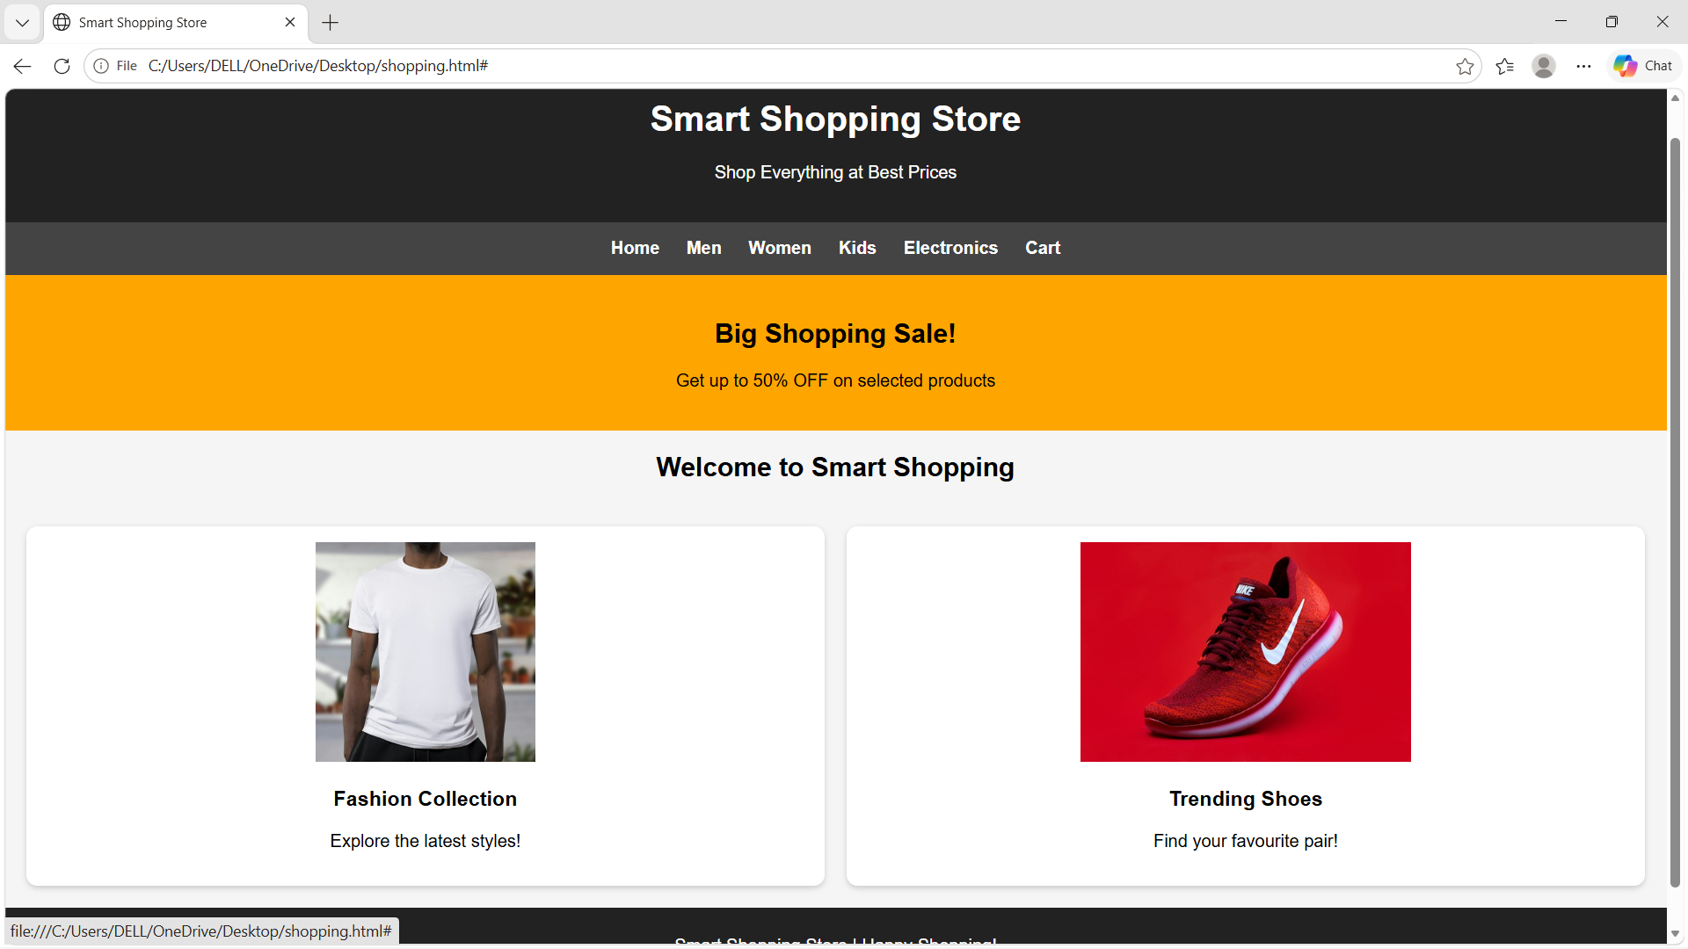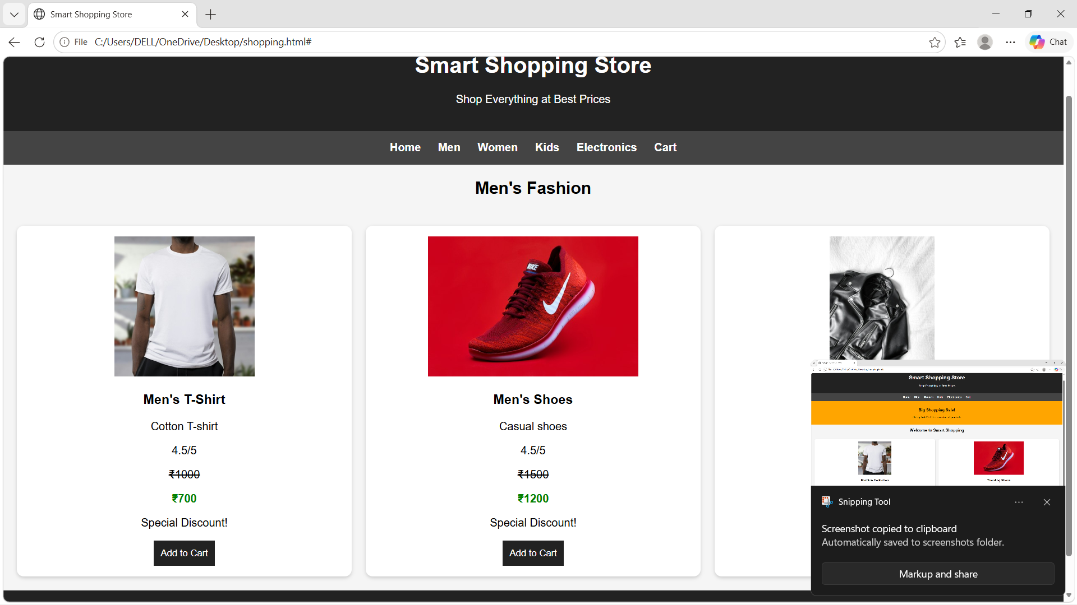
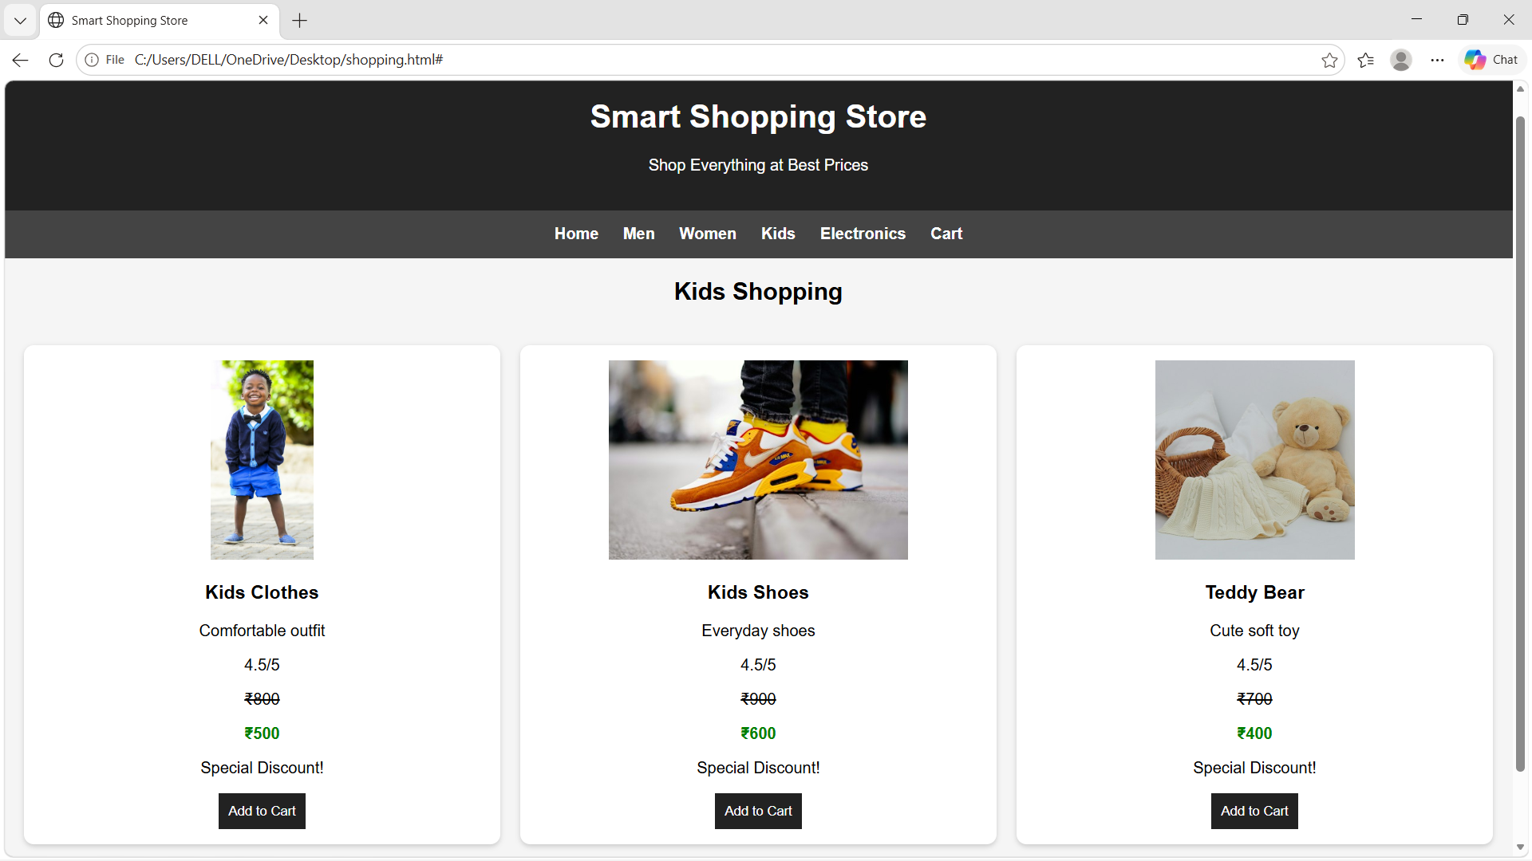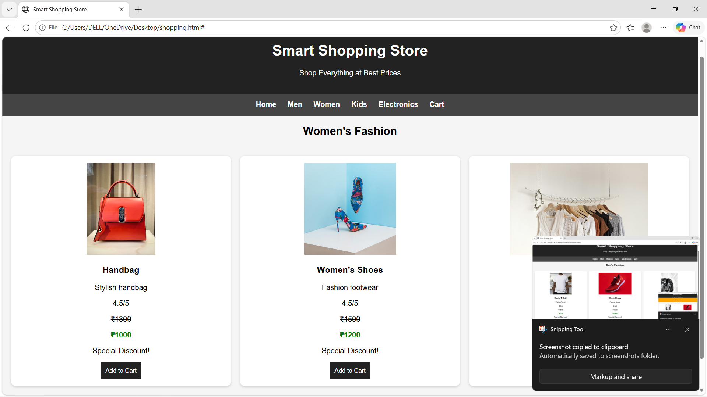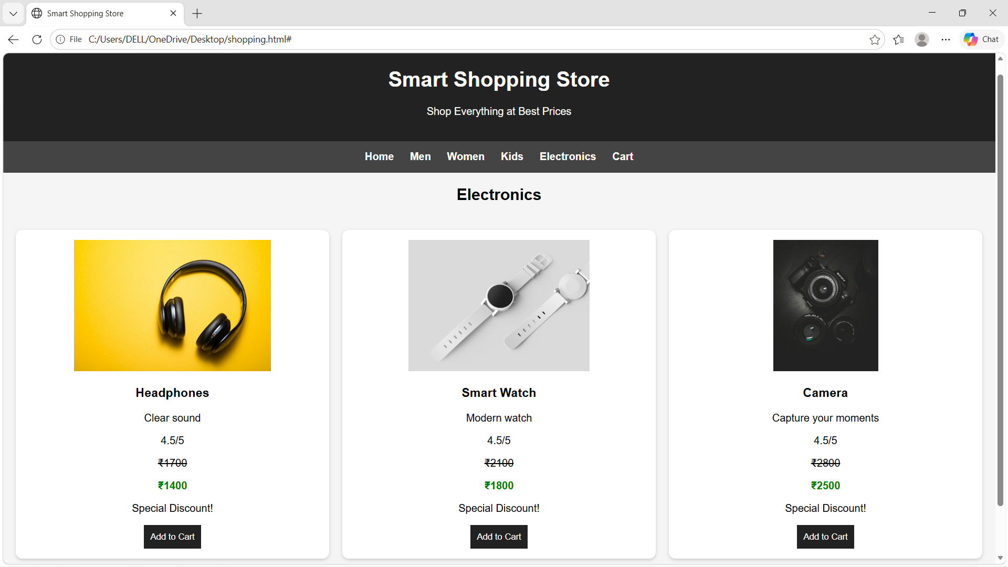

CASE2

Problem statement:
Bakery and Cake Shop Website
Create a website for a bakery displaying cakes, pastries, cookies, custom cake designs, product prices, seasonal offers, and store contact details. Use a visually appealing color scheme and image galleries.

Program code:

<!DOCTYPE html>
<html>
<head>
<title>Sweet Bakery</title>

<style>
body {
font-family: Arial;
margin: 0;
background: #fff0f5;
}

header {
background: #a8325e;
color: white;
text-align: center;
padding: 20px;
}

nav {
background: pink;
padding: 15px;
text-align: center;
}

nav a {
margin: 10px;
text-decoration: none;
color: #702040;
font-weight: bold;
}

h2 {
text-align: center;
color: #a8325e;
}

.products {
display: grid;
grid-template-columns: repeat(auto-fit, minmax(200px, 1fr));
gap: 20px;
padding: 20px;
}

.card {
background: white;
padding: 15px;
text-align: center;
border-radius: 10px;
}

.card img {
width: 100%;
height: 180px;
object-fit: cover;
border-radius: 10px;
}

button {
background: #a8325e;
color: white;
padding: 10px;
border: none;
cursor: pointer;
}

footer {
background: #a8325e;
color: white;
text-align: center;
padding: 10px;
}
</style>
</head>

<body>

<header>
<h1>Sweet Bakery</h1>
<p>Fresh Cakes, Pastries and Cookies</p>
</header>

<nav>
<a href="#" onclick="showPage('home')">Home</a>
<a href="#" onclick="showPage('cakes')">Cakes</a>
<a href="#" onclick="showPage('pastries')">Pastries</a>
<a href="#" onclick="showPage('cookies')">Cookies</a>
<a href="#" onclick="showPage('custom')">Custom Cakes</a>
<a href="#" onclick="showPage('offers')">Offers</a>
<a href="#" onclick="showPage('contact')">Contact</a>
</nav>

<div id="content"></div>

<footer>
<p>Sweet Bakery | Freshness in Every Bite!</p>
</footer>

<script>
function showPage(page) {
let content = document.getElementById("content");

if (page == "home") {
content.innerHTML = `
<h2>Welcome to Sweet Bakery</h2>
<div class="products">
<div class="card">
<img src="https://placehold.co/300x180?text=Delicious+Cakes">
<h3>Delicious Cakes</h3>
<p>Fresh and tasty cakes for everyone!</p>
</div>
<div class="card">
<img src="https://placehold.co/300x180?text=Fresh+Pastries">
<h3>Fresh Pastries</h3>
<p>Enjoy our delicious pastries.</p>
</div>
</div>`;
}

else if (page == "cakes") {
content.innerHTML = `
<h2>Our Cakes</h2>
<div class="products">
<div class="card">
<img src="https://placehold.co/300x180?text=Chocolate+Cake">
<h3>Chocolate Cake</h3>
<p>Price: ₹500</p>
</div>
<div class="card">
<img src="https://placehold.co/300x180?text=Strawberry+Cake">
<h3>Strawberry Cake</h3>
<p>Price: ₹600</p>
</div>
</div>`;
}

else if (page == "pastries") {
content.innerHTML = `
<h2>Our Pastries</h2>
<div class="products">
<div class="card">
<img src="https://placehold.co/300x180?text=Chocolate+Pastry">
<h3>Chocolate Pastry</h3>
<p>Price: ₹80</p>
</div>
<div class="card">
<img src="https://placehold.co/300x180?text=Vanilla+Pastry">
<h3>Vanilla Pastry</h3>
<p>Price: ₹70</p>
</div>
</div>`;
}

else if (page == "cookies") {
content.innerHTML = `
<h2>Our Cookies</h2>
<div class="products">
<div class="card">
<img src="https://placehold.co/300x180?text=Chocolate+Cookies">
<h3>Chocolate Cookies</h3>
<p>Price: ₹150 per pack</p>
</div>
<div class="card">
<img src="https://placehold.co/300x180?text=Butter+Cookies">
<h3>Butter Cookies</h3>
<p>Price: ₹120 per pack</p>
</div>
</div>`;
}

else if (page == "custom") {
content.innerHTML = `
<h2>Custom Cake Designs</h2>
<div class="products">
<div class="card">
<img src="https://placehold.co/300x180?text=Birthday+Cake">
<h3>Birthday Cake</h3>
<p>Price: ₹800 onwards</p>
</div>
<div class="card">
<img src="https://placehold.co/300x180?text=Wedding+Cake">
<h3>Wedding Cake</h3>
<p>Price: ₹2000 onwards</p>
</div>
</div>`;
}

else if (page == "offers") {
content.innerHTML = `
<h2>Special Offers</h2>
<div class="products">
<div class="card">
<h3>Festival Offer</h3>
<p>Get 10% OFF on selected cakes!</p>
</div>
<div class="card">
<h3>Birthday Offer</h3>
<p>Enjoy special birthday cake offers!</p>
</div>
</div>`;
}

else if (page == "contact") {
content.innerHTML = `
<h2>Contact Us</h2>
<div class="card">
<p>Address: Main Road, Vijayawada</p>
<p>Phone: 9876543210</p>
<p>Email: sweetbakery@gmail.com</p>
<p>Opening Hours: 9 AM to 9 PM</p>
</div>`;
}
}

showPage('home');
</script>

</body>
</html>

output:
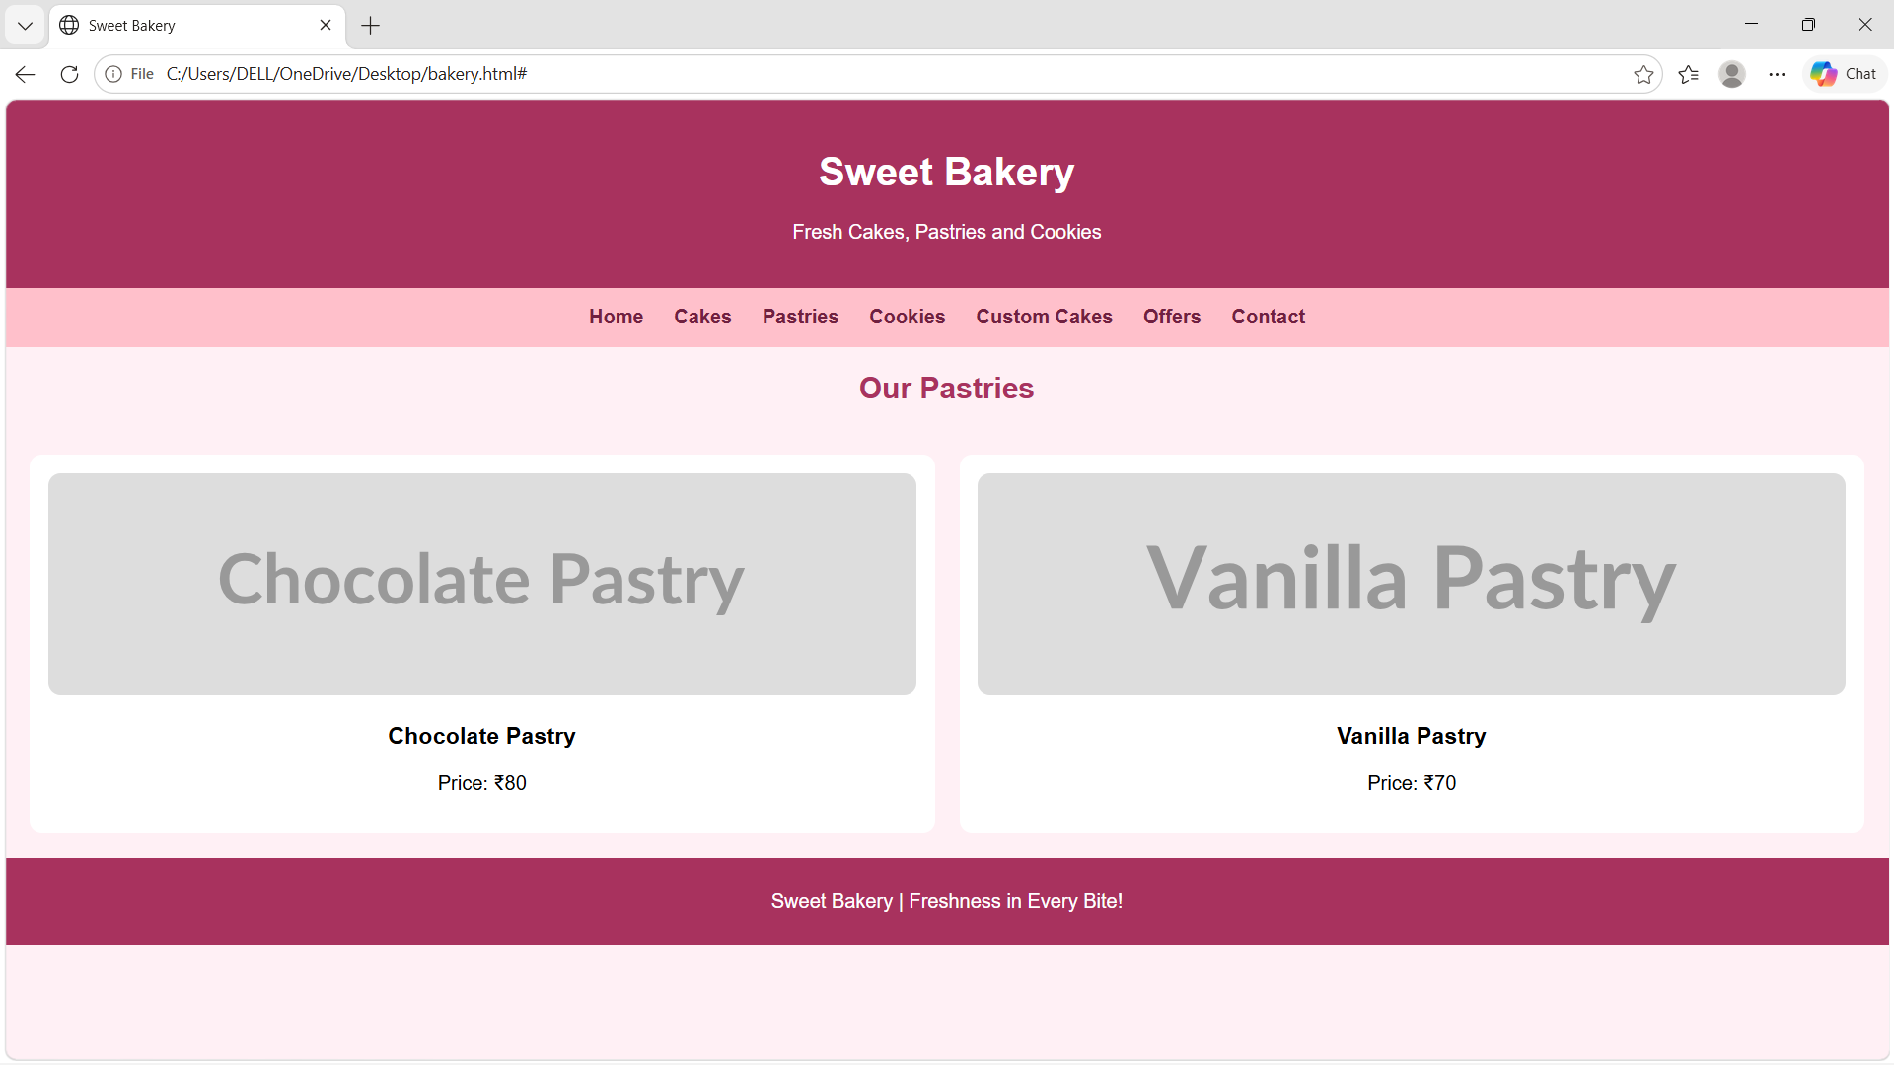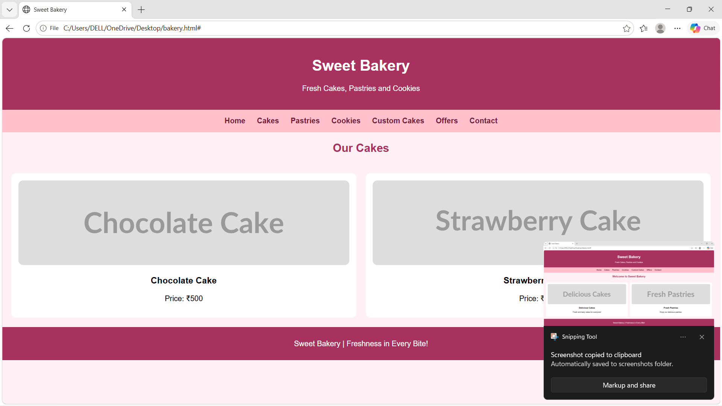
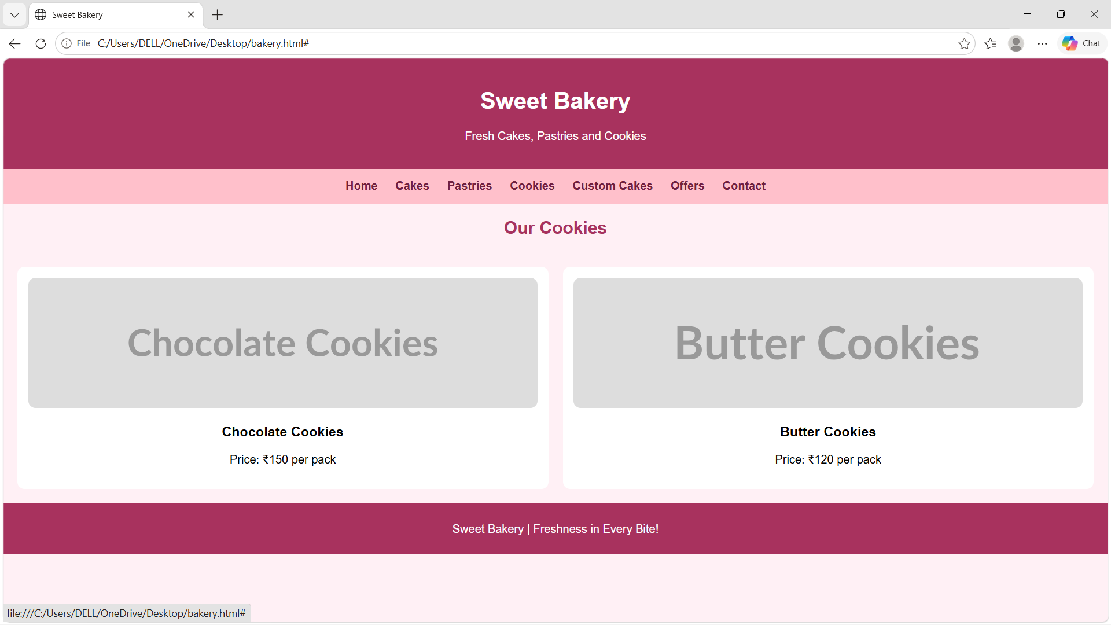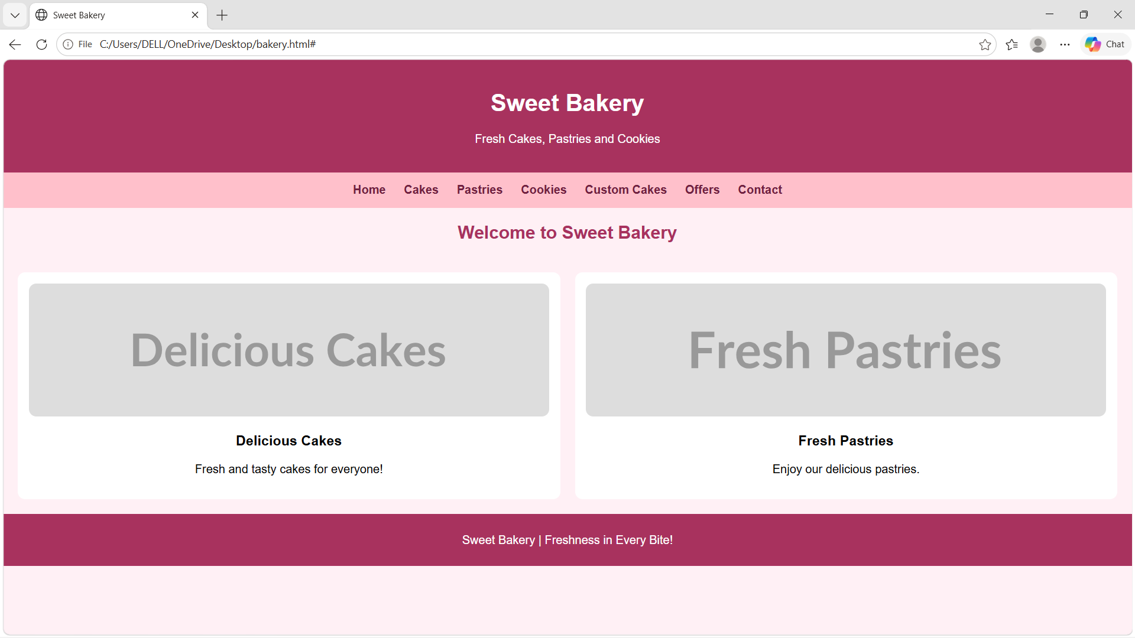

CASE3

Problem statement:
Movie Review and Rating Website
Create a movie website featuring film posters, genres, release dates, cast information, synopsis, critic reviews, and rating displays. Use responsive grids and visually appealing movie cards

Program code:

<!DOCTYPE html>
<html>
<head>
<title>Movie Website</title>
<style>
body {
background: #222;
color: white;
text-align: center;
font-family: Arial;
}

.movie {
display: inline-block;
margin: 15px;
}

img {
width: 180px;
height: 250px;
border-radius: 10px;
}
</style>
</head>
<body>

<h1>🎬 Movie Reviews</h1>

<div class="movie">
<img src="https://image.tmdb.org/t/p/w500/8Gxv8gSFCU0XGDykEGv7zR1n2ua.jpg">
<h3>Oppenheimer</h3>
⭐ 8.3/10
</div>

<div class="movie">
<img src="https://image.tmdb.org/t/p/w500/1pdfLvkbY9ohJlCjQH2CZjjYVvJ.jpg">
<h3>Avatar</h3>
⭐ 7.9/10
</div>

<div class="movie">
<img src="https://image.tmdb.org/t/p/w500/q6y0Go1tsGEsmtFryDOJo3dEmqu.jpg">
<h3>The Shawshank Redemption</h3>
⭐ 9.3/10
</div>

<div class="movie">
<img src="https://image.tmdb.org/t/p/w500/8Y43POKjjKDGI9MH89NW0NAzzp8.jpg">
<h3>Free Guy</h3>
⭐ 7.1/10
</div>

</body>
</html>

output: